Jonnalagadla Sreekaree

proddatur, Andhra Pradesh jonnalagadlasreekaree@gmail.com +91 8639653773

# **Summary**

Looking forward for an innovative, challenging career with a progressive organization that gives me the scope to apply my knowledge and skills for the growth of organization.

**Education**

B. Tech

G. Pullaiah College of Engineering and Technology • Kurnool, Andhra Pradesh 08/2024

# Intermediate

Sri Chaitanya Junior College • Tirupati, Andhra Pradesh

03/2020

# SSC

Sri Chaitanya Techno School • Nandikotkur, Andhra Pradesh

04/2018

Course completion certificate on SQL in hacker rank

C

ourse completion certificate on cloud foundations in AWS

C

ourse completion certificate on fundamentals of IOT in Udemy

Course completion certificate on HTML & CSS Essentials bootcamp in Let

’

s Upgrade

C

ourse completion certificate on AWS Basics in Learn

Tube

Course completion certificate on Python for Data Science in IBM

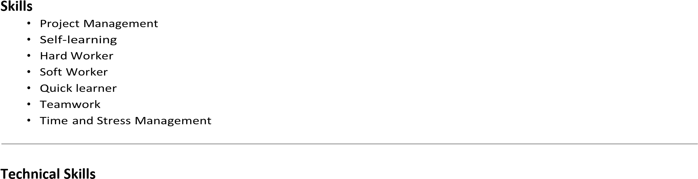

**Certifications**

## Projects

* **Home Automation**

Description: Home automation using simple IoT technology involves connecting devices and appliances in your home to the internet, enabling you to control them remotely using a cloud technology Adafruit IO. This can include everything from turning lights on and off, adjusting the temperature and even monitoring your home security system.

* **Smart Parking System**

Description: A smart parking system using IR sensors and simple IoT technology involves using infrared sensors to detect the presence of vehicles in parking spots and transmit that data to a cloud-based platform using internet connectivity.

* **Automatic Streetlights**

Description: Automatic Street lights sensors using simple IoT technology involves using sensors automatically turning street lights on and off accordingly. This system uses a combination of sensors, controllers, and communication technologies to monitor and control street lighting systems in real-time.

* **Smart Gym (In Progress)**

Description: The project is divided into three modules. At first module the working equipment are connected in parallel. The physical energy is generated while working out. This power is collected and converted into electrical energy using microcontroller. In the second module, the collected electric power is used for lights and for other electrical devices. The third modules includes When a person enter into the gym the sensor must scan the person’s body and should suggest the exercise plan to him. The third module involves Mini Games like Levitation, Tic-Tak-Toe, Memory Game.

* **Smart Agriculture and Plant disease Detection**

Description: smart agriculture system that can monitor and control the soil moisture level and detect plant diseases using MIT app inventor, esp8266, soil moisture sensor and Arduino IoT dashboards. The system consists of a mobile application that communicates with a cloud server and an esp8266 module that connects to the soil moisture sensor and a camera. The mobile application allows the user to set the desired soil moisture level and receive alerts when the level is too low or too high. The camera captures images of the plant leaves and sends them to the cloud server, where a machine learning model analyzes them and identifies any diseases. The user can also view the soil moisture level and the disease status on the Arduino IoT dashboards. The system aims to improve the efficiency and productivity of agriculture by providing real-time feedback and automation.

**Experience**

# Intern

MSMF – My Skills My Future• Kurnool, Andhra Pradesh

01/01/2023 - 31/03/2023

HTML, CSS, JS,BOOTSTRAP,REACT

# Intern

Oasis Infobyte • Kurnool, Andhra Pradesh

01/02/2023 - 31/03/2023

HTML, CSS, Basics of JS

# Intern

Make Skilled • Kurnool, Andhra Pradesh

07/2022 - 08/2022

IOT Application Development and Basics of ML, Worked on Different MicroControllers Such as Arduino, Raspberrypi, ESP32, NodeMCU etc.

## Declaration

I hereby declare that the above-mentioned information is correct up to my knowledge and I bear the responsibility for the correctness of the above-mentioned particulars.

**Signature**

**J.Sreekaree**